**Official exam- first session 2021**

**Exercise 1 ( 5 points) Huntigton disease**

**Huntington disease is a rare neurodegenerative disease of the central nervous system. It is characterized by uncoordinated and involuntary movements of great amplitude and by psychological problems. It is due to a mutation at the level of the gene coding fo**r **a protein called huntingtin which is essential for the survival of the neurons.**

1. Pick out from the text:

Document 1

* 1. The origin of Huntington disease.
  2. The symptoms of this disease.

A study is performed on individuals carrying the mutated allele responsible for this disease. Document 2 represents the variation of the percentage of individuals showing the symptoms of the disease as a function of their age.

|  |  |  |  |  |  |
| --- | --- | --- | --- | --- | --- |
| **Age (years)** | 10 | 30 | 40 | 60 | 70 |
| **Percentage of individuals showing the symptoms of the disease (**%) | 0 | 30 | 60 | 90 | 100 |

Document 2

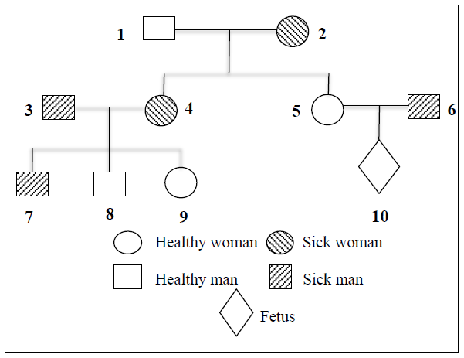

1. Interpret the obtained results.

Document 3 shows the genealogical tree of a family which certain members are affected by the disease.

1. Indicate whether the allele of this disease is recessive or dominant. Justify the answer.
2. Determine the localization of the gene responsible for this disease.

DNA analysis is performed on certain individuals of this family using the Southern blot method. The used probe permits to distinguish the mutated allele from the normal one of the studied gene. The obtained results are shown in document 4.

Document 3

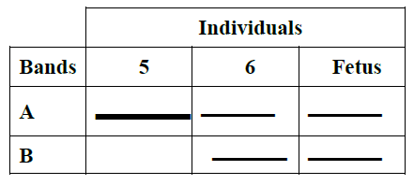

1. Specify the band which corresponds to the mutated allele.
2. Determine the genotype and the phenotype of the fetus.

Document 4

|  |  |  |
| --- | --- | --- |
| Answer key | Grading | 5 |
| Exercise 1 |  | 5 |
| * 1. The origin of Huntington disease is a mutation at the level of the gene coding for a protein called huntingtin. | All or none | 0.5 |
| * 1. The symptoms of this disease are uncoordinated and involuntary movements of great amplitude and psychological problems. | All or none | 0.5 |
| 1. **This is the analysis part** The percentage of individuals showing the symptoms of the disease increases from 0 % to 100% as the age of these individuals increases from 10 to 70 years.   **This is the significance part** This shows that, the expression of Huntington disease symptoms is enhanced with age.  OR  **This is the significance part** This shows that, the expression of Huntington disease symptoms and age are proportional.  (accepted)  OR  **This is the significance part** This shows that, aging provoke the expression of Huntington disease symptoms.  (accepted) | Without analysis none  Without significance  None  Without values remove 1 point  Without unit remove 0.25 for every missing unit  Correct analysis bit incorrect significance 0.75  Correct significance but incorrect analysis 0.75 | 1.5 |
| 1. The mutated allele is dominant over the normal allele because the affected parents (3 and 4) have healthy children (8 and 9). ( the only accepted answer, no other examples from pidegree).This means that the allele for normal is present in the parents but it is masked ( hidden) by the allele responsible for the disease. (D = allele responsible for Huntington disease; n = normal allele) D> n | Justification 0.25  Answer 0.25  ALL or none | 0.5 |
| 1. **Rule:** If the allele responsible for the disease is carried on the non –homologous segment of chromosome Y **inheritance** then, it should be transmitted from father to son; however the affected father (3) has a healthy son (8). Therefore, the allele is not carried by the non-homologous segment of chromosome Y. ( 0.25)   OR  **Rule:** If the allele responsible for the disease is carried on the non –homologous segment of chromosome Y **inheritance** then, every affected father should have an affected boy; the affected father (3) must have a genotype XYD , his son (8) must have inherited the diseased allele YD from his father. So he must also be affected with genotype XYD but he is normal, which is not the case. Therefore, the allele is not carried by the non-homologous segment of chromosome Y.  **Rule:**If the allele of the disease is carried on the non-homologous segment of chromosome X, **inheritance** then the affected father (3) must have should transmit this dominant allele to all his daughters who should be all affected; however, his daughter (9) is healthy, thus the allele is not carried on the non-homologous segment of X chromosome. (0.25)  **OR**  **Rule:**If the allele of the disease is carried on the non-homologous segment of chromosome X, **inheritance** then every affected father must have an affected daughter, then the affected father (3) must have a genotype XDY, his daughter (9) should have inherited an X allele from each parent, so she should take XD from paternal origon. So she must be affected but she is healthy, which is not the case, thus the allele is not carried on the non-homologous segment of X chromosome. (0.25)  If the allele is carried on the homologous segment of chromosome X and Y, then boy (8) who is normal should have the genotype Xn Yn, inheriting Xn from his mother(4) and Yn from his father (3). His sister (9) who is normal should have the genotype XnXn taking Xn from her father (3) and therefore he should have the genotype XnYn and should be healthy but it is not the case.  Therefore, the allele is not carried by the homologous segment of chromosomes X and Y. (0.25)  Hence the allele responsible for the disease is carried on an autosome. ( 0.25) | Every justification 0.25  Missing rule remove 0.25  Missing inheritance remove 0.25 | 1 |
| 1. The band at the level of B corresponds to the mutant allele (0.25). This is because the DNA analysis of individual 5 who is healthy shows only a thick band at the level of A indicating that band A corresponds to the normal allele (0.25). On the other hand, individual 6 who is diseased shows 2 thin bands at the level of A and another at the level of B (0.25). Hence, that band at the level of B corresponds to the mutant allele which is responsible for the disease. (0.25) | No justification remove 0.5  Remove 0.25 for every incorrect justification | 1 |
| 1. Since the fetus has two thin bands at the levels of A and B corresponding to the normal allele and mutant allele respectively 0.5, then the genotype of the fetus is D//n (0.25). Since the mutant allele D is dominant over the normal allele n, the phenotype of the fetus is [D]. (0.25) | All or none  Only answer without justification zero  Without genotype remove 0.25  Without phenotype remove 0.25  Without phenotype and genotype zero | 1 |

**First session 2022**

**Exercise 1 (5 points) Hemophilia B**

Hemophilia B is characterized by the absence of blood clotting which may lead to significant bleeding. It is due to mutations in the F9 gene coding for the coagulation factor IX. The severity of the clinical manifestations depends on the severity of the factor IX deficiency: if the biological activity of the coagulation factor is less than 1%, hemophilia is severe. However, if it is between 5 and 40% hemophilia is minor.

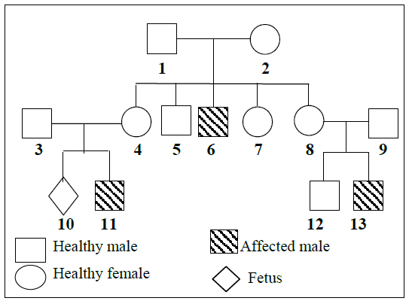

1. Pick out from the text:
   1. the cause of hemophilia B.
   2. the consequence of hemophilia B.

Document 1 shows the genealogical tree of a family in which some members are affected with hemophilia B.

1. Specify whether the allele responsible for hemophilia B is dominant or recessive.
2. Show that the gene responsible for hemophilia B might be located on the non-homologous segment of the X chromosome.

Document 1

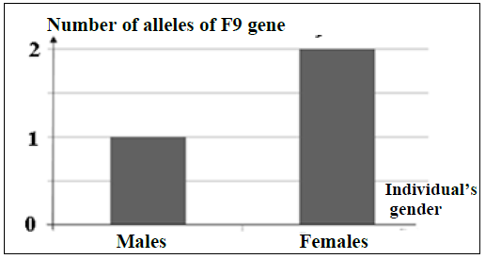

Document 2 represents the number of alleles of the studied gene in males and females.

1. Do the results of document 2 confirm the localization of the F9 gene on the non-homologous segment of the X chromosome? Justify the answer.

Document 2

Using a specialized technique, a DNA analysis of F9 gene in couple (3-4) and in the fetus 10 is carried out. Several DNA fragments are obtained, the size of which can be measured in kilobases (document 3).

1. 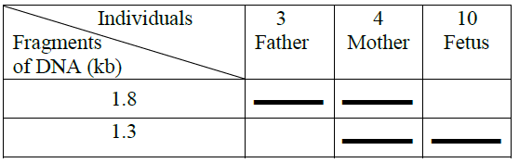Identify, from document 3, the fragment that corresponds to hemophilia B allele.
2. Draw out the phenotype of the fetus 10.

Document 3

|  |  |  |
| --- | --- | --- |
| Answer key | Grading | 5 |
| Exercise 1 |  | 5 |
| * 1. It is caused by mutations in the F9 gene coding for the coagulation factor IX. | All or none | 0.5 |
| * 1. Hemophilia B is characterized by the absence of blood clotting which may lead to significant bleeding. | All or none | 0.5 |
| 1. The allele responsible for hemophilia is recessive 0.25 because the normal parents 1 and 2 gave birth to a diseased child 6. 0.25   This means that the allele responsible for the disease (d) is present in the genotype of at least one of the 2 parents and it is masked by the normal dominant allele (N). 0.25 | Only answer 0.25  Only justification 0.25 | 0.75 |
| 1. Since the disease affects only males, then the gene is sex-linked.0.25   Since the affected boy 6 has a normal father 1, then this gene is not located on the non-homologous segment of Y 0.25. Therefore it might be localized on the non-homologous segment of X. 0.25  **OR**  Since the disease affects only males, then sex discrimination is present and this contradicts with mendle’s law. then the gene is sex-linked and not autosomal 0.25  Rule : If the gene responsible for the disease is localized on the non-homologous segment of Y,inheritance: then every affected boy must have an affected father. Inheritance Then boy 6 is affected must have a genotype XYd , he inherited the affected allele Yd from his father 1 who also should have a genotype XYd  but he is normal which is not the case  Therefore it might be localized on the non-homologous segment of X. 0.25 | Every justification 0.25  Missing rule remove 0.25  Missing inheritance remove 0.25 | 0.75 |
| 1. **Yes 0.25**. If the gene is localized on homologous autosomes or on homologous segment of X and Y, then the number of alleles of F9 gene in males and females should be two, but it is not the case.0.25   If the gene is localized on the non homologous segment of Y, then the females should not have any allele for the gene, which is not the case. Since the number of alleles in the females is two.0.25 **If the gene is localized on the non homologous segment of x, then the male should possess one allele of the gene while the female should possess two alleles of the gene. 0.25**  **OR**  Yes 0.25 In this document, the number of alleles in male is 1 which is less than that in females which is 2.  This is not the case of gene localized on homologous autosomes or on homologous segment of X and Y since in this case the number of alleles should be identical in males and females which is 2. 0.25  If the gene is localized on the non homologous segment of Y, then the females should not have any allele for the gene, which is not the case. Since the number of alleles in the females is two.0.25  **If the gene is localized on the non homologous segment of x, then the male should possess one allele of the gene while the female should possess two alleles of the gene. Which is the case. 0.25** | Every justification 0.25  Missing rule remove 0.25  Missing value remove 0.25 | 1 |
| 1. The DNA analysis of father 3 who is normal and whose genotype is XNY shows one band at the level of 1.8 Kb, (0.25) then this band corresponds to the normal allele. (0.25)   Mother 4 who is normal but has a diseased child 11 is of genotype XNXd. (0.25)  Her DNA analysis shows two bands at the level of 1.8 Kb, which corresponds to the normal allele and another band at the level of 1.3 Kb which corresponds to the allele of the disease. (0.25) | Every genotype 0.25  Each justification 0.25 | 1 |
| 1. The fetus 10 is affected with hemophilia B. | No justification is needed | 0.5 |

**Exercise 2 (5 points) Albinism**

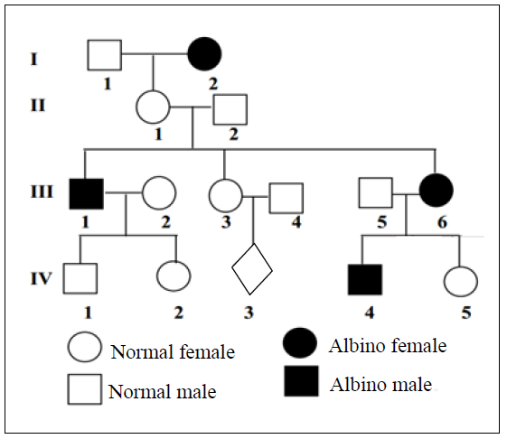Albinism is a hereditary autosomal and recessive disease caused by the absence of melanin, a pigment responsible for hair color. Document 1 represents the pedigree of a family where some members are affected by the disease.

1. Indicate the genotypes of individuals I-1, II-1, and III-6.

In the population where this family lives, among each 100 normal individuals 15 are heterozygous.

1. Determine the genetic risk for the fetus IV-3 to be albino.

Researchers have identified gene E1 coding for enzyme E1 and gene E2 coding for enzyme E2. These enzymes are essential for the synthesis of melanin according to the following reactions:

Document 1

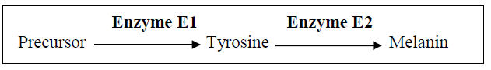

To find the exact origin of albinism in this family, the researchers determined the nucleotide sequences of specific parts of the non-transcribed DNA strand of gene E1 (document 2a) and gene E2 (document 2b) for a normal individual and an albino individual of this family.

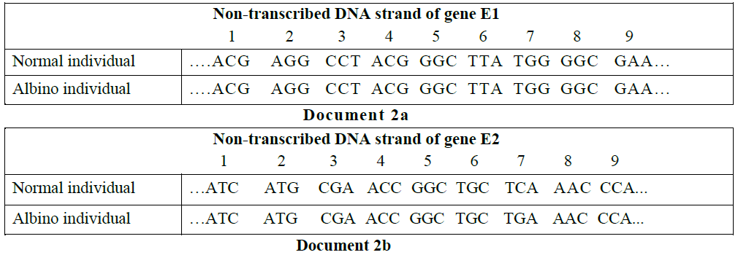

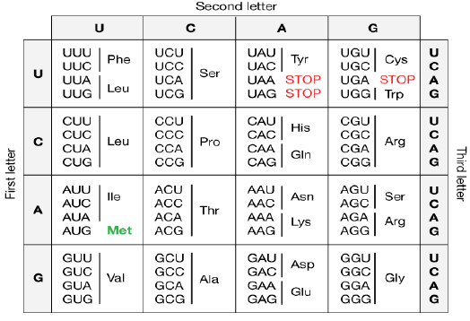

1. Show that the gene responsible for albinism in this family is gene E2.
2. Determine, using the genetic code (document 3), the amino acid sequence of enzyme E2 that corresponds to each of the two individuals, the normal and the albino.
3. Explain how the modification in the nucleotide sequence of the allele coding for enzyme E2 leads to albinism in this family.

Document 3

|  |  |  |
| --- | --- | --- |
| Answer key | Grading | 5 |
| 1. N; norrmal dominant   a: affected recessive 0.25  Genotype I-1 N//N or N//a 0.25 ( if only 1 example either N//N or N//a not both zero)  Genotype II-1 N//a 0.25  Genotype III-6. a//a 0.25 | Alleles 0.25  Genotypes 0.25 each | 1 |
| 1. **Genetic Risk**=   frequency of father to be hetero X frequency of mother to be hetero X probability of having an affected child  frequency of father III-4 to be hetero = 15/100 (no family history) 0.25  frequency of mother III-3 to be hetero =2/3 (having affected brother or sister) 0.25  probability of having an affected child = ¼ 0.25  **Genetic Risk**= 15/100 X 2/3 X 1/4 = 10/400 = 1/40 0.25  OR   1. **Genetic Risk**= P paternal X P maternal ( not essential)   frequency of father to be hetero X frequency to provide a gamete carrying d X frequency of mother to be hetero X frequency to provide a gamete carrying d frequency of father III-4 to be hetero = 15/100 (he belongs to population, no family history) 0.25  frequency of mother III-3 to be hetero =2/3 (having affected brother or sister) 0.25  both parents have a heterozygote genotype, so ½ gametes will be affected (d) and passed to descendants. frequency to provide a gamete carrying d= ½ 0.25  **Genetic Risk**= 15/100 X 1/2 X 2/3 X 1/2 = 10/400 = 1/40 0.25 | Each rule + justification 0.25  If any part is missing, zero  If only final answer without the rule and justification, zero | 1 |
| 1. **Since mutation is observed only at the level of gene E2, where in the** seventh triplet the second nitrogenous base C in the normal individual is substituted by T in the albino individual. 0.5   Therefore, the gene responsible for albinism in this family is gene E2 only. 0.5  OR  At the at the level of gene E1, both the normal and affected individual show an identical nucleotide sequence at the level of the non transcribed strand of DNA however at the level of gene E2 both non transcribed strand of DNA show identical sequence except seventh triplet the second nitrogenous base C in the normal individual is substituted by T in the albino individual 0.5  Therefore, the gene responsible for albinism in this family is gene E2 only. 0.5 | Without only remove 0.25 | 1 |
| 1. **The transcribed strand of the normal individual**   TAG – TAC –GCT–TGG–CGG–ACG– AGT– TTG GGT...  The m RNA **of the normal individual**:  AUC – AUG – CGA–ACC–GGC–UGC– U**C**A– AAC CCA... 0.25  The amino acid sequence of the normal individual:  Ile – Met – Arg– Thr - Gly – Cys – Ser – Asn– Pro –0.25  **The transcribed strand of the albino individual**  TAG –TAC GCT–TGG–CGG–ACG– A**C**T– TTG GGT...  The m RNA **of the albino individual**:  AUC AUG CGA–ACC–GGC–UGC– U**G**A– AAC CCA...0.25  The amino acid sequence of the normal individual:  Ile – Met – Arg– Thr - Gly – Cys 0.25 |  | 1 |
| 1. The mutation by substitution at the level of the seventh triplet where the second nitrogenous base C is substituted by G in the mutant allele 0.25   leads to a stop codon in the sequence of nucleotide in the transcribed m RNA. 0.25  The translation of this mRNA results in an incomplete/truncated/ peptide of abnormal 3D structure.0.25  The non-functional E2 enzyme is not able to transform tyrosine into melanin, thus leading to albinism.0.25 | 1 missing info remove 0.25  2 missing info remove 0.5  3 missing info zero | 1 |